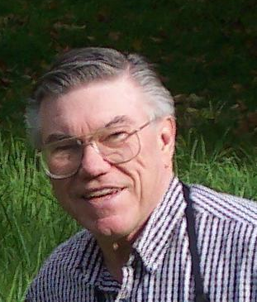
Wayne L. Brillhart Author, Photographer, Speaker
Creator of the CAMIL approach to learning

5 Steps to Better Learning with Photography

Enjoy the wit and wisdom of teacher, Title I Advisor, lecturer and analyst Wayne L. Brillhart as he presents a fun experience about birds. He will also demonstrate how the CAMIL process helps students learn with his book “The Mystery at the Birdfeeder”. Students will enjoy learning about the backyard birds in a context of photographs which add to the reality of the program.
Curiosity Creates Comprehension with CAMIL.

The CAMIL approach to learning:

©
Contact:
Wayne L. Brillhart
P.O. Box 15
Hartland, MI 48353
wayneb@mich.com
(248) 408-7103
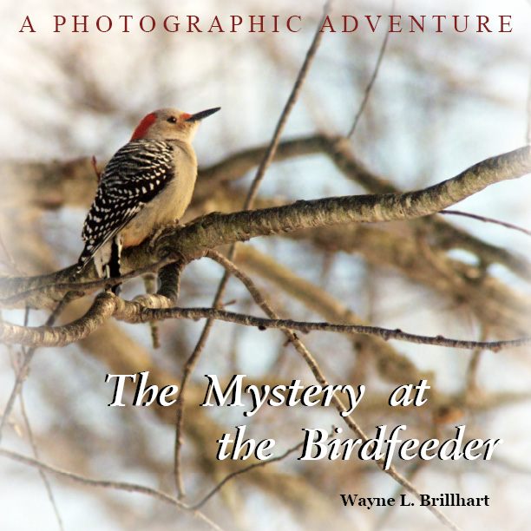

Curiosity promotes
Attention which leads to
Motivation which leads to
Involvement which results in
Learning!

Recent Comments
“ ‘The Mystery at the Birdfeeder’ is the perfect addition to my nature watching classroom.” Third Grade Teacher.
“Every family, every public and school library needs a copy of this wonder full book.” President, national boys organization.
Recent Publications
The Backyard Bird Adventure Series with Rusty and Purdy employs the CAMIL methodology starting with the provoking title; then the adventure advances with Purdy, the English Setter, and sometimes her big brother Rusty seeking clues to solve the mystery. The books are 100% photographs to go with the story line. By the end of the book the reader has learned to recognize the birds in the story as the mystery is revealed. Secondary goals are also accomplished.
The Mystery at the Birdfeeder – Purdy asks the birds for help solving the mystery: Who knocked it down?
The Deer With the Purple Nose – Both Purdy and Rusty get help from the birds to find out how it happened.

Highlights
Over 20 years experience as a teacher of science and mathematics in junior and senior high schools, Title I advisor in mathematics, Specially funded programs in mathematics, Adjunct lecturer in mathematics at University of Michigan – Flint, Taught computer science classes at Wayne State University.
Over 20 years taking photographs as a hobby in Michigan, California, Washington State, China, Tibet, and recently of backyard birds in Michigan.
Other activities include Director of a reading center, personnel work, mergers & acquisitions, project manager, systems analyst, business analyst and author. Also volunteer work with boys and youth receiving the Atlantic Richfield Outstanding Achievement for community service award.

Educational Highlights
A.A. Muskegon Community College – Liberal Arts & Science
A.B. University of Michigan Ann Arbor – Mathematics, Physics
M.A. California State University, Northridge – Administration, Supervision & Higher Education
M. S. Michigan State University – Computer Science
www.wanleepublishing.com www.mysteryatthebirdfeeder.com

