
Wayne L. Brillhart Author, Photographer, Speaker
Creator of the CAMIL approach to learning

What would you like to hear from:

The CAMIL approach to learning: Curiosity promotes Attention which leads to Motivation which leads to Involvement which results in Learning!

©
In The Classroom:
- A casual time when the author reads his book to the students. He can also discuss the birds or the character traits exemplified by the animals in the book.

In The Classroom or Auditorium:
- A PowerPoint presentation on birds in general, birds from the book, or the Birds of Michigan. Can tie in with “The Great Backyard Bird Count” sponsored by Cornell Lab of Ornithology and the Audubon Society encouraging students to be junior scientists.
- How to write a good story.
- Getting the most from your camera (SLR).

For The Teachers:
The CAMIL approach to learning. Focusing on tricks and tips to get the students curious and paying attention.

Recent Comments
“ ‘The Mystery at the Birdfeeder’ is the perfect addition to my nature watching classroom.” Third Grade Teacher.
“Every family, every public and school library needs a copy of this wonder full book.” President, national boys organization.

Recent Publications:
The Mystery at the Birdfeeder – Purdy asks the birds for help solving the mystery: Who knocked the birdfeeder down and ate all the birdseed?
The Deer With the Purple Nose – Both Purdy and her brother Rusty get help from the birds to find out how it the deer got the purple nose. (Coming soon.)
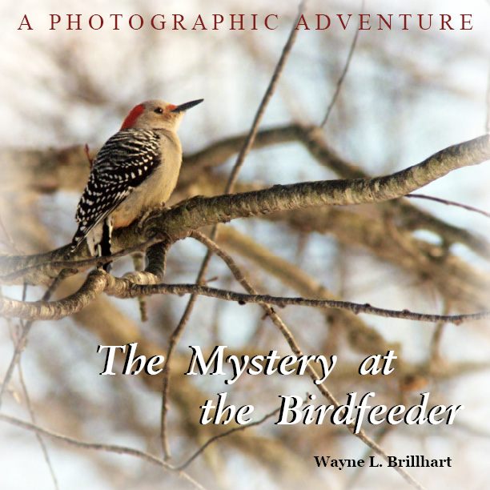

www.wanleepublishing.com www.mysteryatthebirdfeeder.com
Contact: Wayne L. Brillhart P.O. Box 15 Hartland, MI 48353 wayneb@mich.com (248) 408-7103

